KWAME NKRUMAH UNIVERSIATY OF SCIENCE AND TECHNOLOGY
COLLEGE OF ENGINEERING

FACULTY OF MECHANICAL AND AGRICULTURAL ENGINEERING
DEPARTMENT OF MECHANICAL ENGINEERING
AEROPACE ENGINEERING PROGRAM

BsC (Aerospace Engineering), SECOND Semester Examinations, 2018/2019
Third year

AERO 368 Propulsion

May 2019 THREE HOURS

Answer all Problems [Total points 70]

To/T = [1 +(γ-1)M²/2]
TV - DV = wdh + d(wV²/2g);
dt dt
R/C = V(T-D)w
R = uo/(gSFC).(L/D)ln(wi/wf) = h/g.η.(L/D).ln(wi/wf)
η = 2/(1+ue/uo)
g = 9.8m/s²
h2 - h1 = Cp(T2-T1)
P2/p1 = (T2/T1)^{γ(γ-1)}; γ=1.4

Problem 1 [10 points]
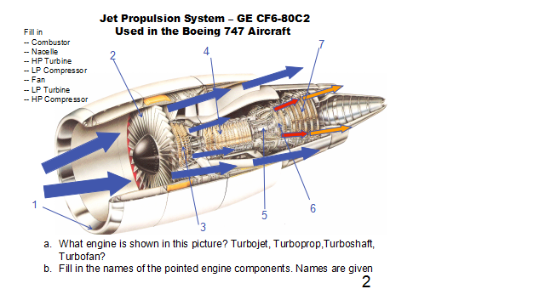

Problem 2 [10 points]
(a)Describe the following propulsion systems (use sketches):
Turbojet
Turbofan
Turboprop
Turboshaft

(b)A turbofan is said to have a bypass ratio of 6. What does it mean?

Problem 3 [10 points]
- Evaluate the surface integral ∫∫ u(ρu.nds) for the flow in figure below. Note: it is a vector!

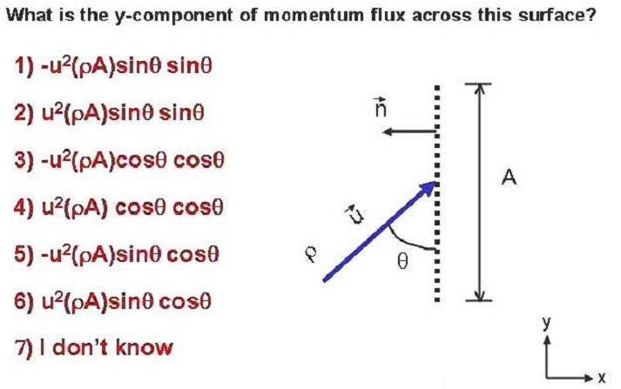

Problem 4 [10 points]
How does a rocket propulsion differ from an air-breathing propulsion?

With an appropriate control volume, use the integral momentum equation to determine the static thrust of a rocket.

Problem 5 [10 points]
Cruise for a new two-engine commercial aircraft will begin at 9 km and it should arrive at this altitude with thrust available to climb at 300 ft/min ( 1.5m/s) while travelling at M=0.85 (250m/s). Assuming that L/D is 16 and that the initial cruise mass is 300,000kg, find the thrust required from each engine to achieve the rate of climb.
- 8820N
- 10,275N
- 17,640N
- 100,695

Problem 6 [10 points]
A) Other forms of overall efficiency of aircraft engines are the specific impulse and thrust specific fuel consumption. Define them both.
B)Give the units of both.
C)How does the range of an aircraft vary with specific fuel consumption.

Problem 7 [10 points]
Calculate the power (horse power) required for a compressor with the following parameters:
Compression ratio p_{T3}/p_{T2} = 10
Mass flow rate mdot = 50kg/s
Compressor entry temperature T_{T2} = 288K
Compressor efficiency η_{c} = (pressure energy available)/(mechanical work expended)
= ( ideal work/actual work) = 0.85

Ideal work = enthalpy change across compressor = mdot.Cp.(T_{T3}-T_{T2})

NOTE: use the ideal isentropic relation p ~ T^{γ/(γ-1)} ; 1kW = 1.31 HP
Air: R = 287 J/kgK; γ = Cp/Cv = 1.4; Cp – Cv = R
1 bar = 10⁵Pa

